Artificial Intelligence – Assignment 4

Abhyudaya Sharma – 1710110019
Kabir Kanha Arora - 1710110165
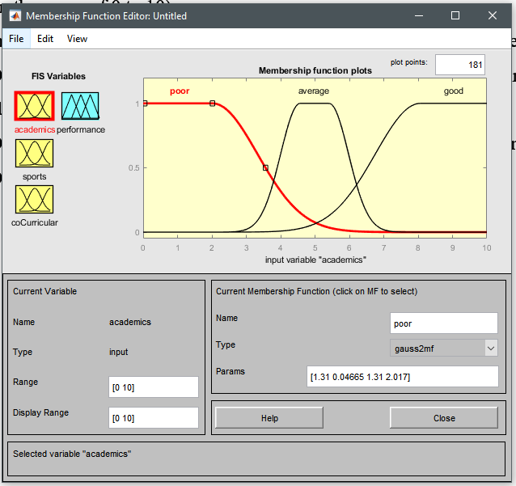
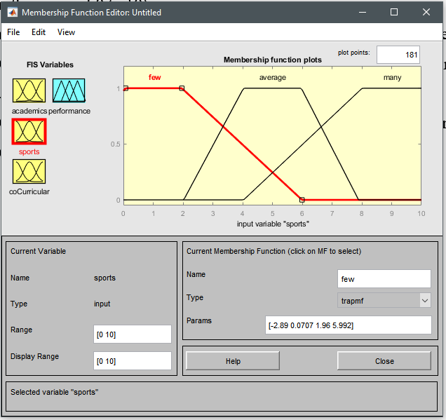
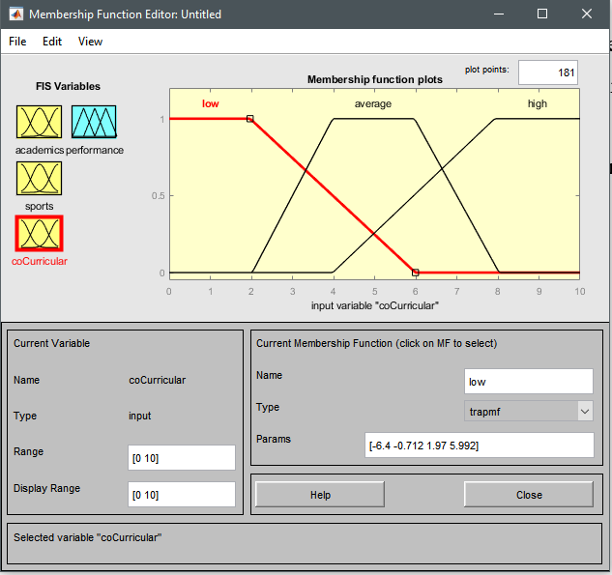
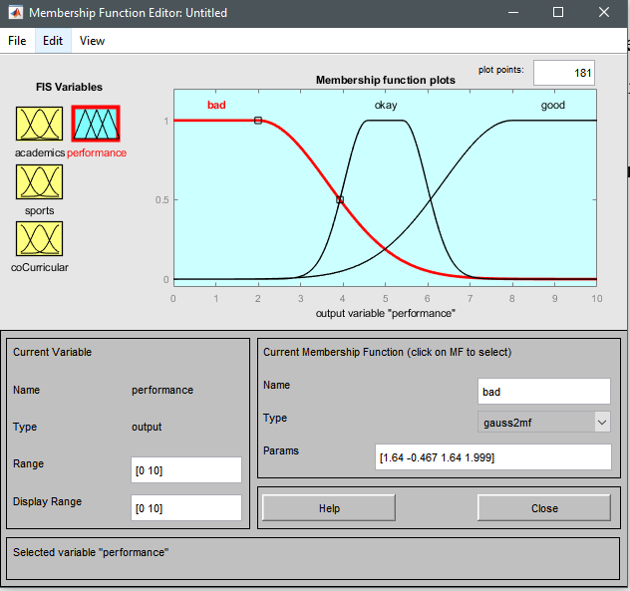
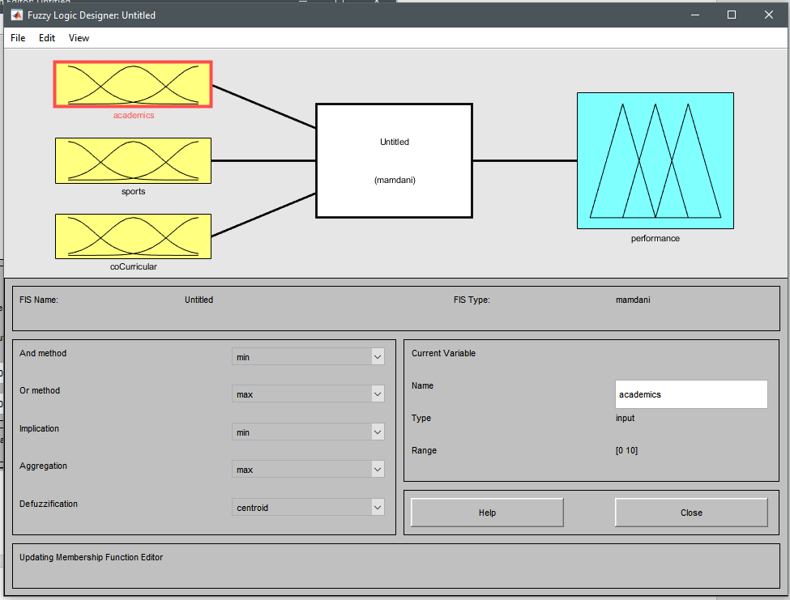
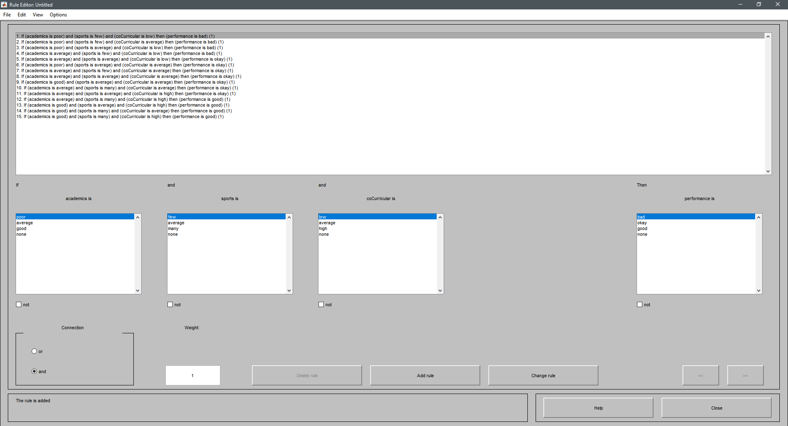
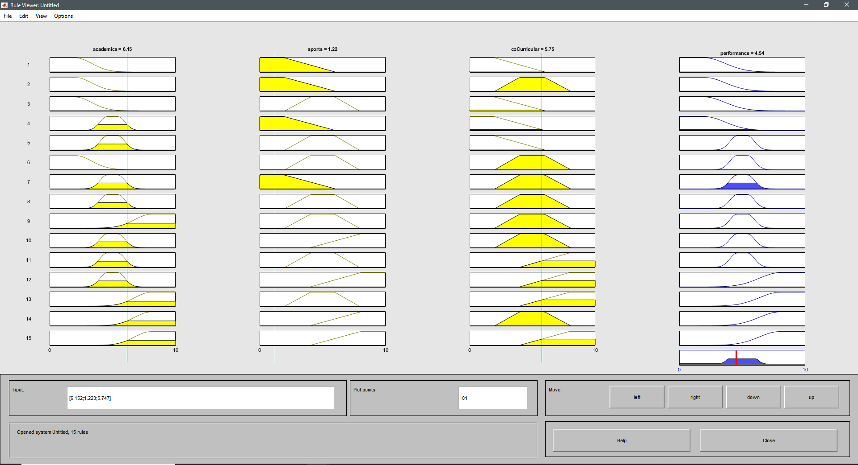
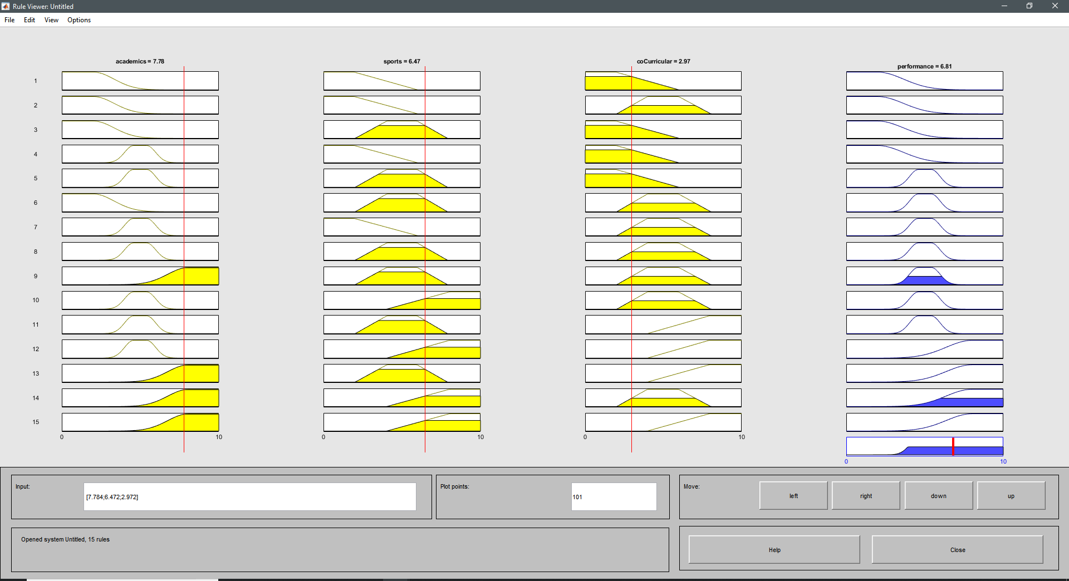
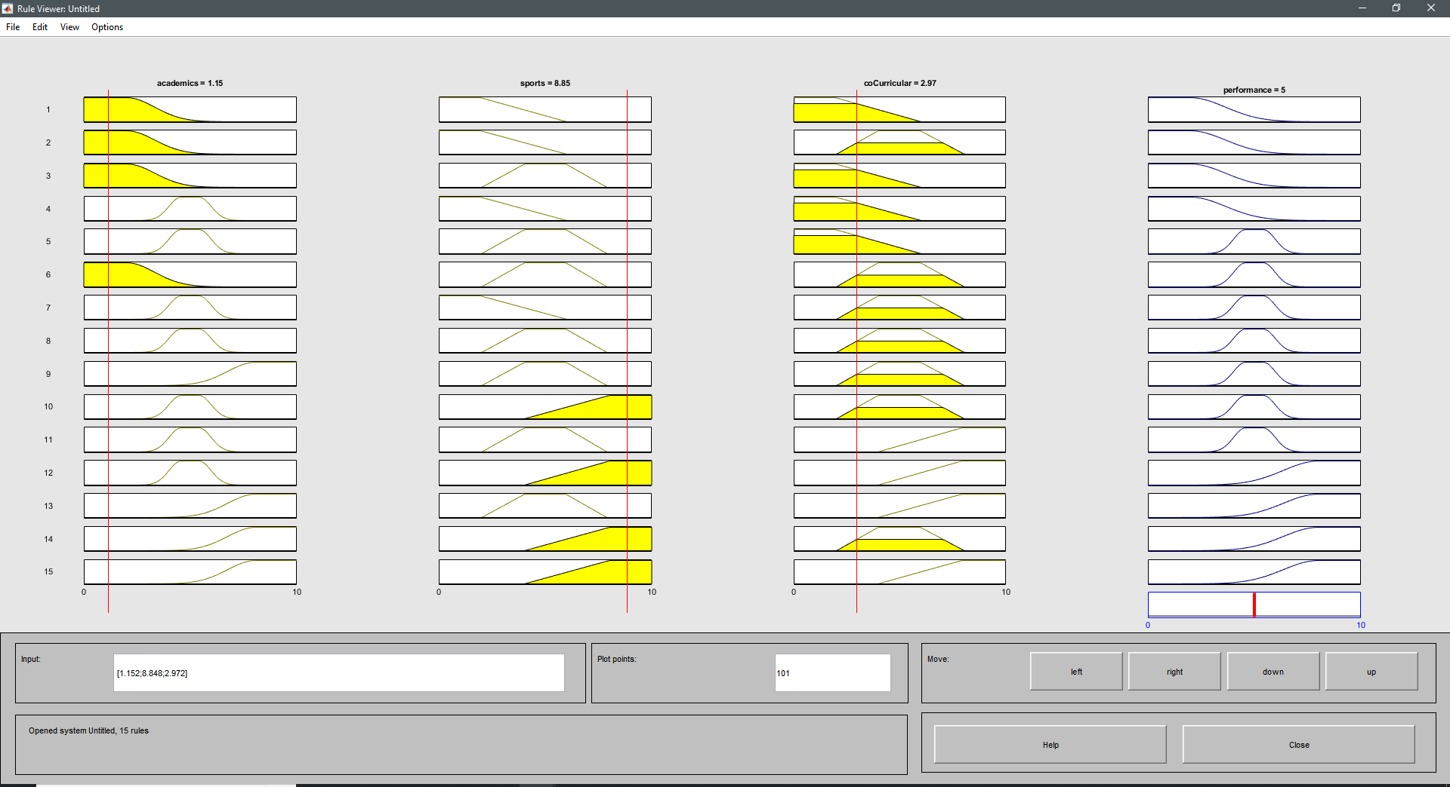

Our choice of graphs
The graphs we chose for the linguistic variables ideally represent the situation we’re trying to model. We chose gauss2mf for academic performance because the CGPA of the students is a number in the subset of the real number domain between 0 and 10. This function clearly distinguishes between the poor, average and good students. This allows us to easily model the situation with smooth movement from one category of academic performance to the next. For the sports performance and co-curricular activities, we ended up using trapmf. With the values falling off quickly because the number of certificates a student can get is an integer number. This allows us to rate the student on the number of certificates he or she gets without trying to approximate the values to a floating point number.
The results produce correct and expected values for the final performance value. This fuzzy logic enables us to grade students on not just one parameter. This is, therefore, a much better estimate of the capabilities of a student. We believe that a similar system should be enabled in our schools and universities to grade the overall development of students while still considering exceptional performance in one or more fields of study to have a positive impact on the calculated performance score.
We would like to conclude with the fact that this model can be much improved and has the potential to revolutionize how students are graded. We believe that further research should be carried out in this direction. After public discourse, agreed-upon ruleset and model should be made the standard at all schools and universities all around the globe.

